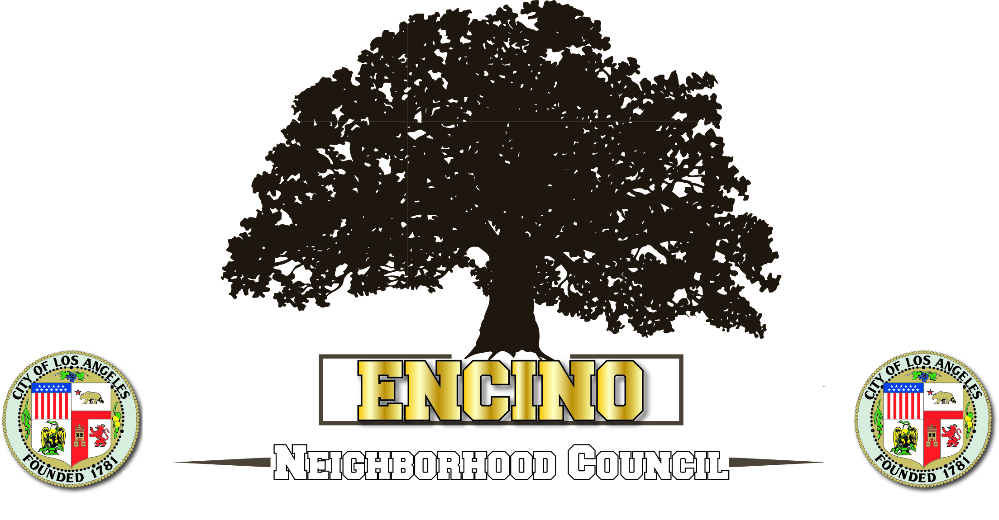
SB-50
March 28, 2019

Councilmember Paul Koretz
15760 Ventura Blvd., Suite 600
Encino, CA 91436

Councilmember Koretz,

The Encino PLU supports Councilman Koretz’s opposition to SB-50 and urges the City Council to oppose passing of Scott Weiner’s’ Bill, for these reasons.

- SB 50 wipes out all single-family zoning within the following “transit” areas
  - SB 50 bans cities from rejecting big residential luxury developments containing a small number of affordable units if A) they are proposed within a ¼-mile radius of a busy bus stop, or B) within a 1/2-mile radius of any rail or train stop.

- SB 50 wipes out single-family zones in 1000s of neighborhoods with good schools
  - SB 50 overturns single-family zoning in areas “above-median income, jobs-rich, with good public schools” that lack major transit (i.e., It allows tall apartments to replace houses in areas with good schools and jobs. Wiener vows these areas will be substantial in size, once the vague definition for "jobs-rich" is decided upon).

- Rewards construction of 85-ft towers next to single-family homes.
  - SB 50 encourages 75-ft and 85-ft-tall luxury towers in single-family areas that are either too close to transit or too close to jobs and good schools. The height limit is NOT 45 feet and 55 feet, as Sen. Scott Wiener falsely implies in SB 50. Add up to 30 feet, under Density Bonus.

If the bill passes the Senate, the Los Angeles City Council should instruct the City Attorney to file suit under the auspices of the City charter as SB 50 violates local governance as outlined in the City Charter.

Thank you,
Alex
Alex Garay
Encino Neighborhood Council
President

