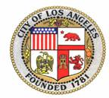 | 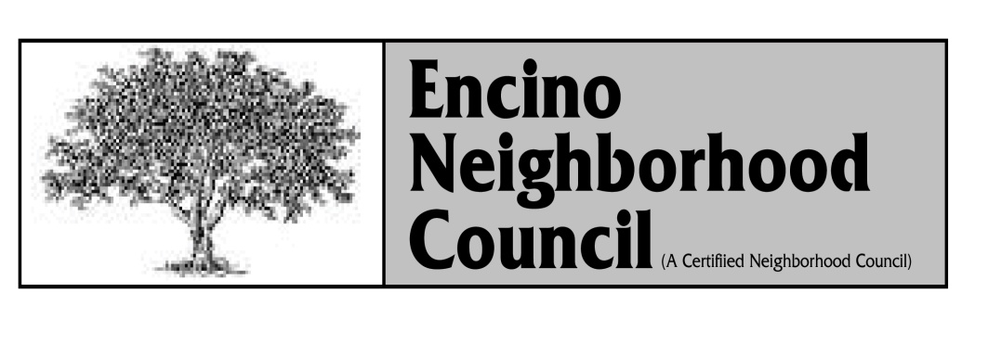  COUNCIL MEETING AGENDA  Wednesday, October 27, 2010  Encino Community Center  4935 Balboa Blvd. Encino  7:00 P.M. | Officers  Louis Krokover  President  Laurie Kelson  Vice President  Michael Kaufman  Treasurer  Shelley Rivlin  Secretary  Gerald A.Silver  Sergeant at Arms  www.encinocouncil.org
 | Food will be served starting at 6:30 PM

MEMBERS OF THE PUBLIC WHO WISH TO ASK A QUESTION ARE REQUESTED TO FILL OUT A FORM AND PROVIDE IT TO THE COUNCIL TO BE READ. PLEASE STATE THE QUESTION AND THE AGENDA ITEM OR PERSON YOU WISH TO DIRECT IT TO

MOTION, DISCUSSION AND VOTE MAY BE TAKEN ON ALL ITEMS ON THE AGENDA

- Call to Order, Pledge of Allegiance, Roll Call, and
Determination of a Quorum and acknowledge alternates

2. Approval of the September General Minutes
[Motion required, unless no objections]

3. Reports from City Officials:
- City Council Offices
Council District 5 - Shawn Bayliss, Jeff Ebenstein
Council District 12 – Semee Park
- LAPD Sr. Lead Officer – Rob Trulik
- LAFD

4. President’s Report (Louis Krokover) Action Protocol Procedures

5. Vice-President’s Report (Laurie Kelson)

6. Treasurer’s Report (Michael Kaufman) Rec & Parks donation of $100.00 for Halloween carnival – September 30, 2010. Approved funding by executive committee.

7. Public Comment:
[Non-Agenda Items] Within the “Board’s” jurisdiction are limited to a maximum of THREE MINUTES per speaker. There will be no responses taken from the public or the board.

7. Guest Speakers:
Ms. Marcia Schneider
League of Women Voters Los Angeles
Information only Pertaining to and Understanding California State Measures (19 thru 27 inclusive) for this coming election – November 2, 2010. Time allowed (30 min.)

LAFD – Battalion Chief Gerry Malais on the current status and position with regard to operations and cut backs and how they will or could affect the community. Time allowed (30 Min.)

8. Committee Reports:
- Executive -- Motion on Supporting the City Wide Motion by Council Members Rosendahl and Koretz to increase the number of animals per household to five for both dogs and cats. This will reduce the number of animals in our shelters, assist in keeping them off the streets and will reduce our costs at the shelters while increasing revenue by licensing and monitoring. This motion passed the executive committee unanimously.

- Traffic / Transportation – Laurie Kelson to discuss for a motion the actions and issues with regard to the I-405 Freeway project as it pertains to the Skirball and Mulholland area locations.

- PLU – (This was not agenized at the last PLU Meeting)
Presentation by Mr. Hiposhi Kawashima for a request to support business use and ABC permit request to the property located at 4926 Balboa Blvd / 16826 Moorpark St.
Case No: DIR-2010-2674-SPP: ENV – 2010-2675-CE. This is the old Chili My Soul location.
This is a time sensitive matter, and a vote is required to go back to the city.

- Parliamentarian – Gerald Silver to discuss clarifications as requested October 2, 2010 & October 3, 2010 with regard to understanding Standing Rulings.

9. Board Member Comments on subject matters within the Board’s Jurisdiction. No responses (Debate) or actions to be taken, as this is only for comment and information.

10. Future Meetings:
A. Next Executive Committee Meeting: November 16, 2010
B. Next ENC General Board Meeting: December 8, 2010

The Encino Neighborhood Council (ENC) is a certified Neighborhood Council of the City of Los Angeles which advises City and other Governmental Officials on issues or concerns that are affecting the community of Encino.

The ENC is made up of elected and volunteer persons who live, work or otherwise are involved in the community of Encino.

The ENC also makes appropriations of City Funds for Community Projects and needs the needs of the community as requested or presented to committees or the general board.

The ENC general meetings are usually held on the 4th Wednesday of each month at the: Encino Community Center, 4935 Balboa Blvd, starting at 7:00pm.

For further information – Please go to: www.encinocouncil.org

PUBLIC INPUT AT ENC MEETINGS - An opportunity for the public to address the Council or Speaker on agenda items will be provided before or during consideration of the item. Members of the public who wish to be recognized on any item are requested to complete a question card for each item they wish to address, and present the completed card(s) to the Sergeant-At-Arms. Speaker cards are available at the back of the meeting room.

The Council will also provide an opportunity for the public to speak on any [Non-Agenda Items*] during “Public Comment”. The Council may not take any action or discuss matters addressed in “Public Comments”. However, the Council President may refer such matters to the appropriate Council Committees for further consideration.

* Public comments are limited to 3 minutes per speaker.

* ENC COUNCIL DISCUSSION AND TIME LIMITS – ENC Councilmember’s requesting to speak will be recognized by the President in the order requested. For any item, the Chairperson of the Committee, or the maker of the original motion shall have up to THREE (3) minutes to discuss the item. Councilmember’s may speak up to TWO (2) minutes each on the matter unless extended by the President or Council. After all members desiring to speak on a question have had an opportunity to be heard once, the time for each Member desiring to speak again shall be limited to a maximum of ONE (1) minute unless extended by the President or Council. A motion calling the “Previous Question” may be introduced by any member during a Council debate.

If adopted, this motion will terminate debate on a matter and the matter will then be submitted for a vote.

VOTING AND DISPOSITION OF ITEMS - Most motions require a majority vote of the Councilmember’s present and voting will be by hand vote unless otherwise decided by the Council.
Unless requested for further consideration by an ENC Councilmember, any item which has been forwarded to the Council by a unanimous committee vote shall be approved as a “Consent Item” without further discussion.

As a covered entity under Title II of the Americans with Disabilities Act, the City of Los Angeles does not
discriminate on the basis of disability and upon request will provide reasonable accommodation to ensure
equal access to its programs, services, and activities.

Sign language interpreters, assisted listening devices, or other auxiliary aids and/or services may be provided upon a written request. To ensure availability of services, please make your request at least 3 business days (72 hours) prior to the meeting by contacting Tom Soong, at (323) 359-2579, toll-free at (866) LA HELPS, or e-mail tsoong@mailbox.lacity.org

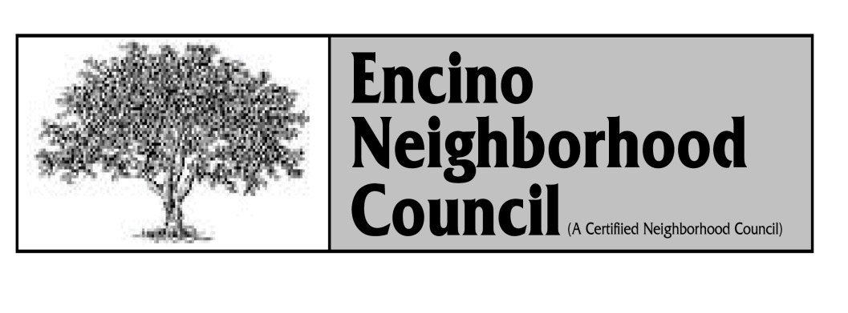

MAIL: P.O. BOX 260439, ENCINO, CA. 91426-0439
VOICEMAILTEL: (818) 817-6998
www.encinocouncil.org

